**Задание 1**

Загружаем Orders.csv в mysql.

CREATE TABLE Orders (

client_id INT,

purchase_date DATE

);

LOAD DATA INFILE 'C:\\ProgramData\\MySQL\\MySQL Server 8.0\\Uploads\\Orders.csv'

INTO TABLE Orders

FIELDS TERMINATED BY ','

LINES TERMINATED BY '\n'

IGNORE 1 ROWS

(@client_id, @purchase_date)

SET client_id = CAST(@client_id AS UNSIGNED),

purchase_date = STR_TO_DATE(@purchase_date, '%m/%d/%Y');

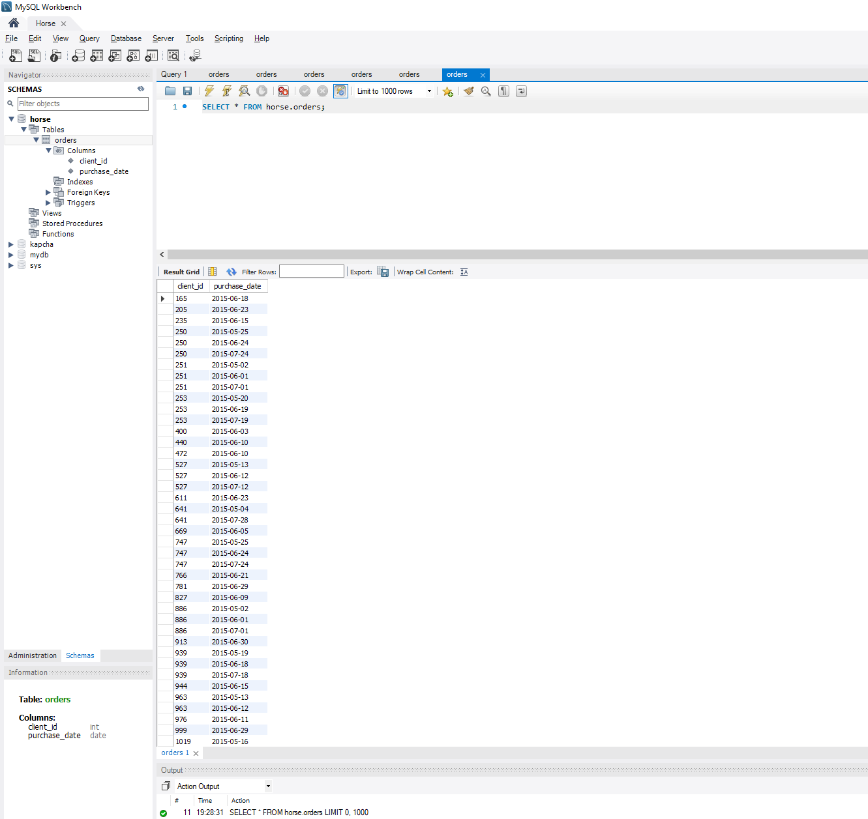

1. **Новые торговые точки:**

WITH first_orders AS (

SELECT client_id, MIN(DATE_FORMAT(purchase_date, '%Y-%m')) AS first_month

FROM Orders

GROUP BY client_id

)

SELECT first_month AS month, COUNT(client_id) AS new_clients

FROM first_orders

GROUP BY first_month

ORDER BY first_month;

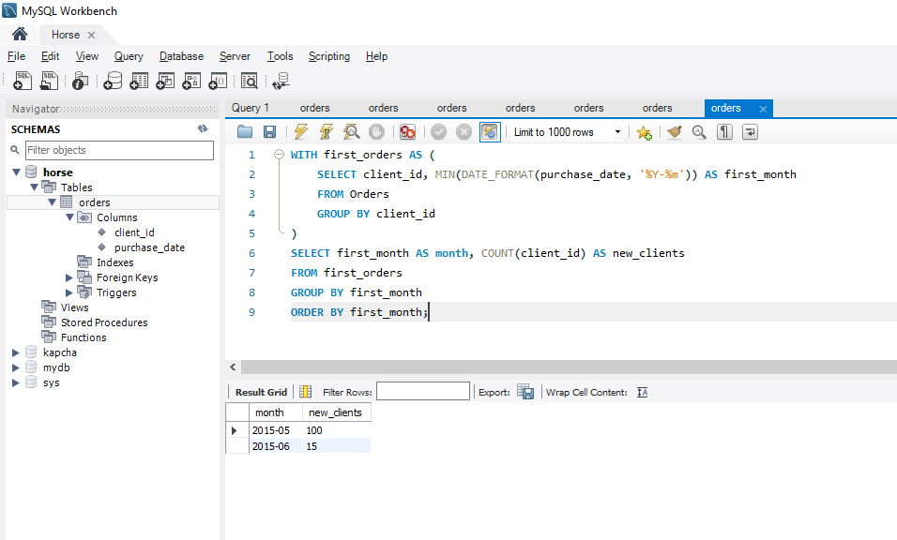

**2. Торговые точки, сделавшие заказ в прошлом месяце и в этом**

WITH orders_per_month AS (

SELECT DISTINCT client_id, DATE_FORMAT(purchase_date, '%Y-%m') AS month

FROM Orders

)

SELECT cur.month, COUNT(cur.client_id) AS retained_clients

FROM orders_per_month cur

JOIN orders_per_month prev

ON cur.client_id = prev.client_id

AND STR_TO_DATE(CONCAT(cur.month, '-01'), '%Y-%m-%d') = DATE_ADD(STR_TO_DATE(CONCAT(prev.month, '-01'), '%Y-%m-%d'), INTERVAL 1 MONTH)

GROUP BY cur.month

ORDER BY cur.month;

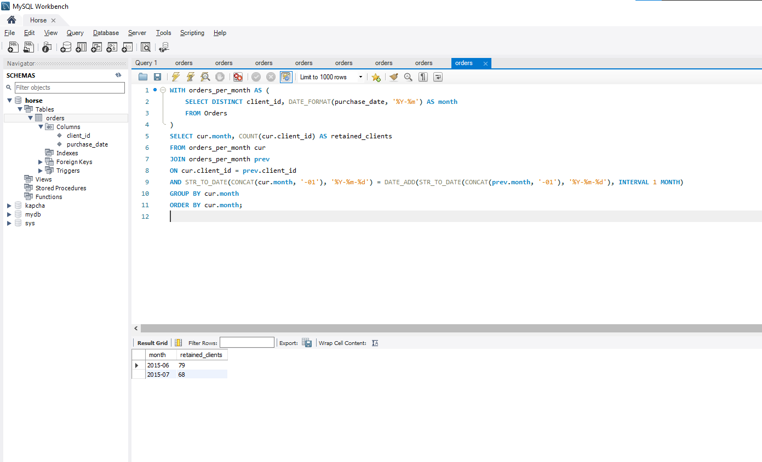

**3. Торговые точки, которые когда-то что-то заказали(только не в прошлом месяце) и вернувшиеся.**

WITH orders_per_month AS (

-- Получаем список уникальных (client_id, month)

SELECT DISTINCT client_id, DATE_FORMAT(purchase_date, '%Y-%m') AS month

FROM Orders

)

SELECT cur.month, COUNT(cur.client_id) AS returned_clients

FROM orders_per_month cur

JOIN orders_per_month prev

ON cur.client_id = prev.client_id

AND STR_TO_DATE(CONCAT(cur.month, '-01'), '%Y-%m-%d') > DATE_ADD(STR_TO_DATE(CONCAT(prev.month, '-01'), '%Y-%m-%d'), INTERVAL 1 MONTH)

GROUP BY cur.month

ORDER BY cur.month;

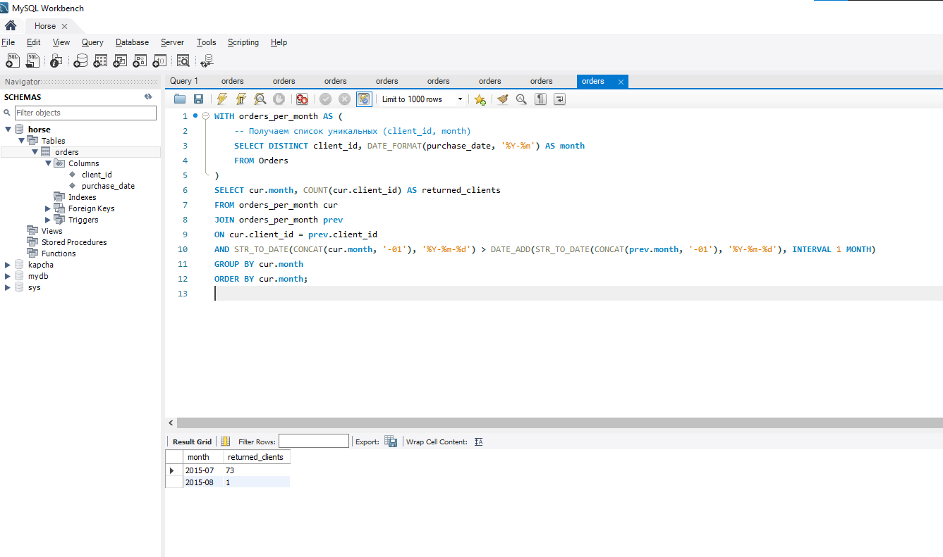

**4. Торговые точки, отвалившиеся в этом месяце.**

WITH orders_per_month AS (

SELECT DISTINCT client_id, DATE_FORMAT(purchase_date, '%Y-%m') AS month

FROM Orders

)

SELECT DATE_FORMAT(

STR_TO_DATE(CONCAT(prev.month, '-01'), '%Y-%m-%d') + INTERVAL 1 MONTH, '%Y-%m'

) AS month,

COUNT(prev.client_id) AS churned_clients

FROM orders_per_month prev

LEFT JOIN orders_per_month cur

ON prev.client_id = cur.client_id

AND cur.month = DATE_FORMAT(

STR_TO_DATE(CONCAT(prev.month, '-01'), '%Y-%m-%d') + INTERVAL 1 MONTH, '%Y-%m'

)

WHERE cur.client_id IS NULL

AND prev.month < (SELECT MAX(month) FROM orders_per_month)

GROUP BY month

ORDER BY month;

